What is Transaction: A unit of action which should be ACID. Ex: Transfer Money from Banking Account A to Banking Account B.

LocalTransaction: Involves 1 resource. Local Transaction is resource specific transaction (for example Database Transactions) and application server has nothing to do with them.

Global Transaction: Global Transaction is an application server managed transaction, allowing to work with different transactional resources (this might be two different database, database and message queue, etc).
https://www.javacodegeeks.com/2013/07/spring-jta-multiple-resource-transactions-in-tomcat-with-atomikos-example.html

Traditional Transaction Management (Programmatic Transaction Management):
A simple transaction management to database using SQL is as follows:
- Begin the transaction using begin transaction command.
- Perform various delete, update or insert operations using SQL queries.
- If all the operation are successful then perform commit otherwise rollback all the operations.
Spring supports both programmatic and declarative transaction management.
- Programmatic transaction management: This means that you have to manage the transaction with the help of programming. That gives you extreme flexibility, but it is difficult to maintain.
- Declarative transaction management: This means you separate transaction management from the business code. You only use annotations or XML based configuration to manage the transactions.
Declarative transaction management is preferable over programmatic transaction management though it is less flexible than programmatic transaction management. Spring supports declarative transaction management through the Spring AOP framework.
Declarative Transaction Management can be done in 2 ways
1) through AOP, business logic doesn't know anything about transaction. Ex: All the method starts with update, delete will start write transaction. get method will start read-only transaction.

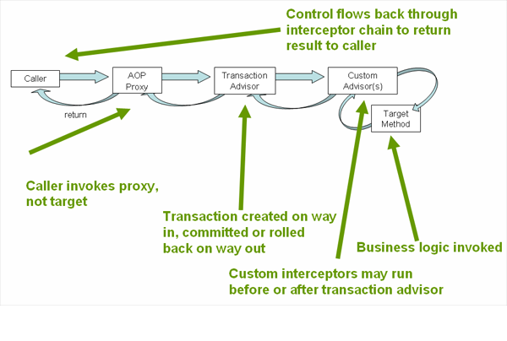 2) Using @Transactional annotation (javax.transaction.Transactional ) : You can place the @Transactional annotation before an interface definition, a method on an interface, a class definition, or a public method on a class.
The presence of the @Transactional annotation is not enough to activate the transactional behavior. The @Transactional annotation is simply metadata that can be consumed by some runtime infrastructure that is @Transactional-aware, So the <tx:annotation-driven/> element is required in declaration xml.

